Scenario
An insurance company had data stored about some American States (NY, WI, IL, NJ, VT, OH, NH, MI, MN, and ME) and the individual insurance policy values in the states. The insurance company would like to know how rural and urban insurance policies increase or decrease the insurance value average within the states. The audience will be from a financial background from America, with basic mathematical skills minimum.
Report summary
Initially, I found the states and the average insured values for each state. Furthermore, I then looked at the average insured values for each state for rural and urban separately. With some states not having any rural insured policies, I eliminated the states without any rural insured policies: NJ, OH, NH, MN, and ME. MI was eliminated as it only has one rural policy.
Now that the data has been cleaned, I wanted to see what percentage of urban policies for each state. To see the bigger picture, I made a graph to display the percentage of policies from highest to lowest percentage of urban policies from the total policies for each state in the cleaned data, Figure 1.
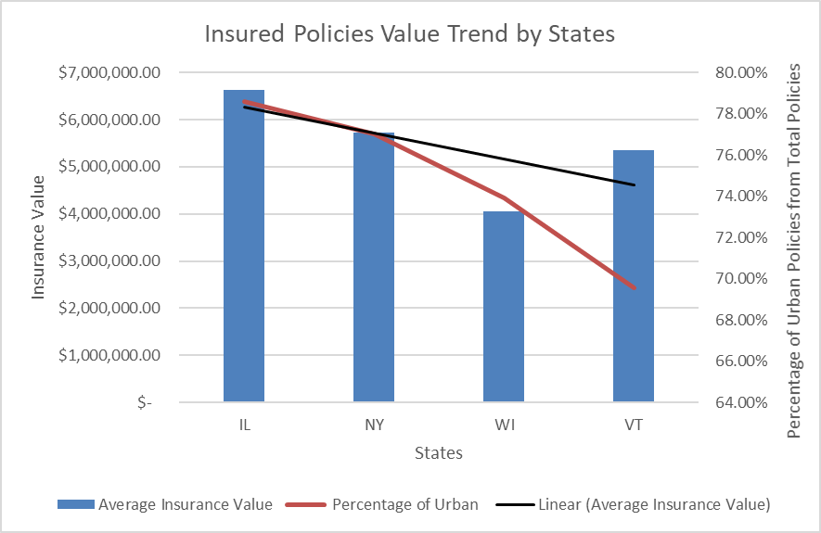
Figure 1
The black line is the trend line of the average insured policy value for each state, while the orange line is the percentage of urban policies compared to the total policies. Figure 1 suggests that the greater the proportion of urban policies to the entire policies for each state, the higher the insured policy value average, suggesting average insured policy values are biased towards the proportion of urban policies compared to the total policies.

